CHAP 1: SW Question:
1.What is software? Computer programs and associated documentation. Software products may be developed for a particular customer or may be developed for a general market. | 2.What are the attributes of good software? Good software should deliver the required functionality and performance to the user and should be maintainable, dependable, and usable. | 3.What is SE? SE is an engineering discipline that is concerned with all aspects of software production. = Software engineering is concerned with theories, methods and tools for professional software development. | 4.What are the fundamental SE activities? Software specification, software development, software validation, and software evolution. | 5.Difference between software engineering vs computer science? Computer science focuses on theory and fundamentals; software engineering is concerned with the practicalities of developing and delivering useful software. | 6.Difference between software engineering vs system engineering? System engineering is concerned with all aspects of computer-based systems development including hardware, software, and process engineering. Software engineering is part of this more general process. | 7.What are the key challenges facing software engineering? Coping with increasing diversity, demands for reduced delivery times, and developing trustworthy software. | 8.What are the costs of software engineering? Roughly 60% of software costs are development costs; 40% are testing costs. For custom software, evolution costs often exceed development costs. | 9.What are the best software engineering techniques and methods? While all software projects have to be professionally managed and developed, different techniques are appropriate for different types of system. For example, games should always be developed using a series of prototypes whereas safety critical control systems require a complete and analyzable specification to be developed. You can’t, therefore, say that one method is better than another. | 10.What differences has the Web made to software engineering? The Web has led to the availability of software services and the possibility of developing highly distributed service-based systems. Web-based systems development has led to important advances in programming languages and software reuse.
Software costs
•Software costs often dominate computer system costs. The costs of software on a PC are often greater than the hardware cost. •Software costs more to maintain than it does to develop. For systems with a long life, maintenance costs may be several times development costs. •Software engineering is concerned with cost-effective software development.
Software project failure: •Increasing system complexity: As new software engineering techniques help us to build larger, more complex systems, the demands change. Systems have to be built and delivered more quickly; larger, even more complex systems are required; systems have to have new capabilities that were previously thought to be impossible. •Failure to use software engineering methods: It is fairly easy to write computer programs without using software engineering methods and techniques. Many companies have drifted into software development as their products and services have evolved. They do not use software engineering methods in their everyday work. Consequently, their software is often more expensive and less reliable than it should be.
Software products:
•Generic products: These are stand-alone systems that are produced by a development organization and sold on the open market to any customer who is able to buy them. Examples of this type of product include software for PCs such as databases, word processors, drawing packages, and project-management tools. It also includes so-called vertical applications designed for some specific purpose such as library information systems, accounting systems, or systems for maintaining dental records. •Customized (or bespoke) products: These are systems that are commissioned by a particular customer. A software contractor develops the software especially for that customer. Examples of this type of software include control systems for electronic devices, systems written to support a particular business process, and air traffic control systems.
Product specification
•Generic products: The specification of what the software should do is owned by the software developer and decisions on software change are made by the developer. •Customized products: The specification of what the software should do is owned by the customer for the software and they make decisions on software changes that are required.
Essential attributes of good software
Maintainability: Software should be written in such a way so that it can evolve to meet the changing needs of customers. This is a critical attribute because software change is an inevitable requirement of a changing business environment.
Dependability and security: Software dependability includes a range of characteristics including reliability, security and safety. Dependable software should not cause physical or economic damage in the event of system failure. Malicious users should not be able to access or damage the system.
Efficiency: Software should not make wasteful use of system resources such as memory and processor cycles. Efficiency therefore includes responsiveness, processing time, memory utilization, etc.
Acceptability: Software must be acceptable to the type of users for which it is designed. This means that it must be understandable, usable and compatible with other systems that they use.
Software engineering is an engineering discipline that is concerned with all aspects of software production from the early stages of system specification through to maintaining the system after it has gone into use. In this definition, there are two key phrases:
1.Engineering discipline: Engineers make things work. They apply theories, methods, and tools where these are appropriate. However, they use them selectively and always try to discover solutions to problems even when there are no applicable theories and methods. Engineers also recognize that they must work to organizational and financial constraints so they look for solutions within these constraints.
2.All aspects of software production Software engineering is not just concerned with the technical processes of software development. It also includes activities such as software project management and the development of tools, methods, and theories to support software production.
Importance of software engineering:
•1.More and more, individuals and society rely on advanced software systems. We need to be able to produce reliable and trustworthy systems economically and quickly. •2.It is usually cheaper, in the long run, to use software engineering methods and techniques for software systems rather than just write the programs as if it was a personal programming project. For most types of systems, the majority of costs are the costs of changing the software after it has gone into use.
Software process activities:
1.Software specification, where customers and engineers define the software that is to be produced and the constraints on its operation. 2.Software development, where the software is designed and programmed. 3.Software validation, where the software is checked to ensure that it is what the customer requires. 4.Software evolution, where the software is modified to reflect changing customer and market requirements.
General issues that affect software:
1.Heterogeneity Increasingly, systems are required to operate as distributed systems across networks that include different types of computer and mobile devices. As well as running on general-purpose computers, software may also have to execute on mobile phones. You often have to integrate new software with older legacy systems written in different programming languages. The challenge here is to develop techniques for building dependable software that is flexible enough to cope with this heterogeneity. 2.Business and social change Business and society are changing incredibly quickly as emerging economies develop and new technologies become available. They need to be able to change their existing software and to rapidly develop new soft- ware. Many traditional software engineering techniques are time consuming and delivery of new systems often takes longer than planned. They need to evolve so that the time required for software to deliver value to its customers is reduced. 3.Security and trust As software is intertwined with all aspects of our lives, it is essential that we can trust that software. This is especially true for remote soft- ware systems accessed through a web page or web service interface. We have to make sure that malicious users cannot attack our software and that information security is maintained. 4.Scale: Software has to be developed across a very wide range of scales, from very small embedded systems in portable or wearable devices through to Internet-scale, cloud-based systems that serve a global community.
Software engineering diversity
•There are many different types of software system and there is no universal set of software techniques that is applicable to all of these. •The software engineering methods and tools used depend on the type of application being developed, the requirements of the customer and the background of the development team.
Application types:
1.Stand-alone applications These are application systems that run on a local computer, such as a PC. They include all necessary functionality and do not need to be connected to a network. Examples of such applications are office applications on a PC, CAD programs, photo manipulation software, etc. 2.Interactive transaction-based applications These are applications that execute on a remote computer and that are accessed by users from their own PCs or terminals. Obviously, these include web applications such as e-commerce applications where you can interact with a remote system to buy goods and services. This class of application also includes business systems, where a business provides access to its systems through a web browser or special-purpose client program and cloud-based services, such as mail and photo sharing. Interactive applications often incorporate a large data store that is accessed and updated in each transaction. 3.Embedded control systems These are software control systems that control and manage hardware devices. Numerically, there are probably more embedded systems than any other type of system. Examples of embedded systems include the software in a mobile (cell) phone, software that controls anti-lock braking in a car, and software in a microwave oven to control the cooking process. 4 Batch processing systems These are business systems that are designed to process data in large batches. They process large numbers of individual inputs to create corresponding outputs. Examples of batch systems include periodic billing systems, such as phone billing systems, and salary payment systems. 5.Entertainment systems These are systems that are primarily for personal use and which are intended to entertain the user. Most of these systems are games of one kind or another. The quality of the user interaction offered is the most important distinguishing characteristic of entertainment systems. 6.Systems for modeling and simulation These are systems that are developed by scientists and engineers to model physical processes or situations, which include many, separate, interacting objects. These are often computationally intensive and require high-performance parallel systems for execution. 7.Data collection systems These are systems that collect data from their environment using a set of sensors and send that data to other systems for processing. The software has to interact with sensors and often is installed in a hostile environment such as inside an engine or in a remote location. 8.Systems of systems These are systems that are composed of a number of other software systems. Some of these may be generic software products, such as a spreadsheet program. Other systems in the assembly may be specially written for that environment.
Software engineering fundamentals: •1.System should be developed using a managed and understood development process. The organization should plan the development process and have clear ideas of what will be produced and when it will be completed. Of course, different processes are used for different types of software. •2.Dependability and performance are important for all types of systems. Software should behave as expected, without failures. It should be safe in its operation and secure against external attack. The system should perform efficiently and should not waste resources. •3.Understanding and managing the software specification and requirements (what the software should do) are important. You have to know what different customers and users of the system expect from it and manage their expectations so that a useful system can be delivered within budget and to schedule. 4.You should reuse software that has already been developed rather than write new software.
Internet software engineering: •The Web is now a platform for running application and organizations are increasingly developing web-based systems rather than local systems. •Web allow application functionality to be accessed over the web. •Cloud computing is an approach to the provision of computer services where applications run remotely on the ‘cloud’: +Users do not buy software buy pay according to use.
Web-based software engineering:
-Web-based systems are complex distributed systems but the fundamental principles of software engineering discussed previously are as applicable to them as they are to any other types of system. -The fundamental ideas of software engineering apply to web-based software in the same way that they apply to other types of software system. -Software reuse: Software reuse is the dominant approach for constructing web- based systems. When building these systems, you think about how you can assemble them from pre-existing software components and systems. -Incremental and agile development: Web-based systems should be developed and delivered incrementally. It is now generally recognized that it is impractical to specify all the requirements for such systems in advance. -Service-oriented systems: Software may be implemented using service-oriented software engineering, where the software components are stand-alone web services. -Rich interfaces: Interface development technologies such as AJAX and HTML5 have emerged that support the creation of rich interfaces within a web browser.
Software engineering ethics:
•Software engineering involves wider responsibilities than simply the application of technical skills. •Software engineers must behave in an honest and ethically responsible way if they are to be respected as professionals. •Ethical behavior is more than simply upholding the law but involves following a set of principles that are morally correct.
Issues of professional responsibility:
•Confidentiality: Engineers should normally respect the confidentiality of their employers or clients irrespective of whether or not a formal confidentiality agreement has been signed. •Competence: Engineers should not misrepresent their level of competence. They should not knowingly accept work which is outwith their competence. •Intellectual property rights: Engineers should be aware of local laws governing the use of intellectual property such as patents, copyright, etc. They should be careful to ensure that the intellectual property of employers and clients is protected. •Computer misuse: Software engineers should not use their technical skills to misuse other people’s computers. Computer misuse ranges from relatively trivial (game playing on an employer’s machine, say) to extremely serious (dissemination of viruses).
ACM/IEEE Code of Ethics
•The professional societies in the US have cooperated to produce a code of ethical practice. •Members of these organizations sign up to the code of practice when they join. •The Code contains eight Principles related to the behavior of and decisions made by professional software engineers, including practitioners, educators, managers, supervisors and policy makers, as well as trainees and students of the profession.
Rationale for the code of ethics: •Computers have a central and growing role in commerce, industry, government, medicine, education, entertainment and society at large. Software engineers are those who contribute by direct participation or by teaching, to the analysis, specification, design, development, certification, maintenance and testing of software systems. •Because of their roles in developing software systems, software engineers have significant opportunities to do good or cause harm, to enable others to do good or cause harm, or to influence others to do good or cause harm. To ensure, as much as possible, that their efforts will be used for good, software engineers must commit themselves to making software engineering a beneficial and respected profession.
Ethical principles
1. Public: Software engineers shall act consistently with the public interest. 2. Client & Employer: Software engineers shall act in a manner that is in the best interests of their client and employer consistent with the public interest. 3. Product: Software engineers shall ensure that their products and related modifications meet the highest professional standards possible. 4. Judgment: Software engineers shall maintain integrity and independence in their professional judgment. 5. Management: Software engineering managers and leaders shall subscribe to and promote an ethical approach to the management of software development and maintenance. 6. Profession: Software engineers shall advance the integrity and reputation of the profession consistent with the public interest. 7. Colleagues: Software engineers shall be fair to and supportive of their colleagues. 8. Self: Software engineers shall participate in lifelong learning regarding the practice of their profession and shall promote an ethical approach to the practice of the profession.
Case studies
-A personal insulin pump: An embedded system in an insulin pump used by diabetics to maintain blood glucose control. Collects data from a blood sugar sensor and calculates the amount of insulin required to be injected.
Calculation based on the rate of change of blood sugar levels. Sends signals to a micro-pump to deliver the correct dose of insulin. Safety-critical system as low blood sugars can lead to brain malfunctioning, coma and death; high-blood sugar levels have long-term consequences such as eye and kidney damage. Insulin pump hardware architecture:
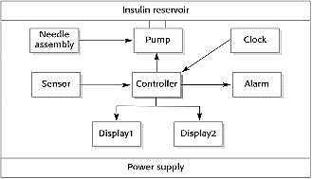
Activity model of the insulin pump: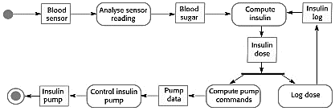
Essential high-level requirements: •The system shall be available to deliver insulin when required. •The system shall perform reliably and deliver the correct amount of insulin to counteract the current level of blood sugar. •The system must therefore be designed and implemented to ensure that the system always meets these requirements.
-A mental health case patient management system: Mentcare. A system used to maintain records of people receiving care for mental health problems. A patient information system for mental health care: •A patient information system to support mental health care is a medical information system that maintains information about patients suffering from mental health problems and the treatments that they have received. •Most mental health patients do not require dedicated hospital treatment but need to attend specialist clinics regularly where they can meet a doctor who has detailed knowledge of their problems. •To make it easier for patients to attend, these clinics are not just run in hospitals. They may also be held in local medical practices or community centres. Mentcare: •Mentcare is an information system that is intended for use in clinics. •It makes use of a centralized database of patient information but has also been designed to run on a PC, so that it may be accessed and used from sites that do not have secure network connectivity. •When the local systems have secure network access, they use patient information in the database but they can download and use local copies of patient records when they are disconnected. Mentcare goals: •To generate management information that allows health service managers to assess performance against local and government targets. •To provide medical staff with timely information to support the treatment of patients. The organization of the Mentcare system:
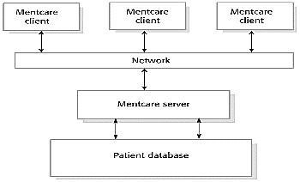
Key features of the Mentcare system: -Individual care management: Clinicians can create records for patients, edit the information in the system, view patient history, etc. The system supports data summaries so that doctors can quickly learn about the key problems and treatments that have been prescribed. -Patient monitoring: The system monitors the records of patients that are involved in treatment and issues warnings if possible problems are detected. -Administrative reporting: The system generates monthly management reports showing the number of patients treated at each clinic, the number of patients who have entered and left the care system, number of patients sectioned, the drugs prescribed and their costs, etc.
Mentcare system concerns: -Privacy: It is essential that patient information is confidential and is never disclosed to anyone apart from authorised medical staff and the patient themselves. -Safety: +Some mental illnesses cause patients to become suicidal or a danger to other people. Wherever possible, the system should warn medical staff about potentially suicidal or dangerous patients. +The system must be available when needed otherwise safety may be compromised and it may be impossible to prescribe the correct medication to patients.
-A wilderness weather station: A data collection system that collects data about weather conditions in remote areas.
Wilderness weather station: •The government of a country with large areas of wilderness decides to deploy several hundred weather stations in remote areas. •Weather stations collect data from a set of instruments that measure temperature and pressure, sunshine, rainfall, wind speed and wind direction: +The weather station includes a number of instruments that measure weather parameters such as the wind speed and direction, the ground and air temperatures, the barometric pressure and the rainfall over a 24-hour period. Each of these instruments is controlled by a software system that takes parameter readings periodically and manages the data collected from the instruments.
The weather station’s environment:
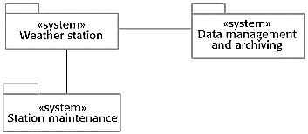
Weather information system: •The weather station system: This is responsible for collecting weather data, carrying out some initial data processing and transmitting it to the data management system. •The data management and archiving system: This system collects the data from all of the wilderness weather stations, carries out data processing and analysis and archives the data. •The station maintenance system: This system can communicate by satellite with all wilderness weather stations to monitor the health of these systems and provide reports of problems.
Additional software functionality: •Monitor the instruments, power and communication hardware and report faults to the management system. -Manage the system power, ensuring that batteries are charged whenever the environmental conditions permit but also that generators are shut down in potentially damaging weather conditions, such as high wind. •Support dynamic reconfiguration where parts of the software are replaced with new versions and where backup instruments are switched into the system in the event of system failure.
-iLearn: a digital learning environment: A system to support learning in schools.
A digital learning environment: •A digital learning environment is a framework in which a set of general-purpose and specially designed tools for learning may be embedded plus a set of applications that are geared to the needs of the learners using the system. •The tools included in each version of the environment are chosen by teachers and learners to suit their specific needs: +These can be general applications such as spreadsheets, learning management applications such as a Virtual Learning Environment (VLE) to manage homework submission and assessment, games and simulations.
Service-oriented systems: •The system is a service-oriented system with all system components considered to be a replaceable service. •This allows the system to be updated incrementally as new services become available. •It also makes it possible to rapidly configure the system to create versions of the environment for different groups such as very young children who cannot read, senior students, etc.
iLearn services: •Utility services that provide basic application- independent functionality and which may be used by other services in the system. •Application services that provide specific applications such as email, conferencing, photo sharing etc. and access to specific educational content such as scientific films or historical resources. •Configuration services that are used to adapt the environment with a specific set of application services and do define how services are shared between students, teachers and their parents. iLearn architecture:
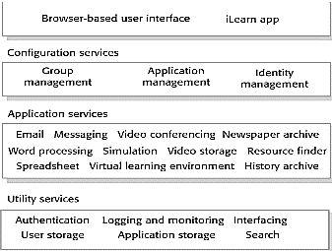
iLearn service integration: •Integrated services are services which offer an API (application programming interface) and which can be accessed by other services through that API. Direct service-to-service communication is therefore possible. •Independent services are services which are simply accessed through a browser interface and which operate independently of other services. Information can only be shared with other services through explicit user actions such as copy and paste; re-authentication may be required for each independent service.
Key points: •Software engineering is an engineering discipline that is concerned with all aspects of software production. •Essential software product attributes are maintainability, dependability and security, efficiency and acceptability. •The high-level activities of specification, development, validation and evolution are part of all software processes. •The fundamental notions of software engineering are universally applicable to all types of system development. •There are many different types of system and each requires appropriate software engineering tools and techniques for their development. •The fundamental ideas of software engineering are applicable to all types of software system. •Software engineers have responsibilities to the engineering profession and society. They should not simply be concerned with technical issues. •Professional societies publish codes of conduct which set out the standards of behavior expected of their members.
CHAP 2: Software processes
1. What is a software process? What are the fundamental activities that are common to all software processes?
A structured set of activities required to develop a software system.
●Software specification ●Software design and implementation●Software validation●Software evolution
2. What is software process model? List the 3 generic process models that are used in software engineering?
A software process model is an abstract representation of a process.
● The waterfall model ●Incremental development●Reuse-oriented software engineering
3. Why are iterations usually limited when the waterfall model is used?
The waterfall model is a document-driven model with documents produced at the end of each phase. Because of the cost of producing and approving documents, iterations and costly and involve significant rework. Hence they are limited.
4. What are the three benefits of incremental development, compared to the waterfall model?
● The cost of accommodating changes to customer requirements is
reduced. ● It is easier to get customer feedback on development work that has been done. ● More rapid delivery and deployment of useful software to the customer is possible ●
5. What are the development stages in reuse-based development?
● Component analysis ● Requirements modification●System design with reuse ●Development and integration
2.1. Giving reasons for your answer based on the type of system being developed, suggest the most appropriate generic software process model that might be used as a basis for managing the development of the following systems: ● A course registration system ● An online bookstore system ● A university accounting system that replaces an existing system
● An interactive travel planning system that helps users plan journeys with the lowest environmental impact
● A course registration system: If this system is developed at the first time, it will require a lot of up-front analysis before implementation. It certainly needs a plan driven approach to development with the requirements carefully analysed. A waterfall model is therefore the most appropriate approach to use, perhaps with formal transformations between the different development stages. If there are some similar existing systems, we can apply a reuse-based approach. ● An online bookstore system: This is a system where the requirements will change to adapt new customer needs. Incremental development with, perhaps, some UI prototyping is the most appropriate model. An agile process may be used. In some cases, if some similar systems have been developed and the requirements are simple, a reuse-based approach might be applied. ● University accounting system: This is a system whose requirements are fairly well-known and which will be used in an environment in conjunction with lots of other systems such as a research grant management system. Therefore, a reuse based approach is likely to be appropriate for this. ● Interactive travel planning system: System with a complex user interface but which must be stable and reliable. An incremental development approach is the most appropriate as the system requirements will change as real user experience with the system is gained.

The software process
•A software process is a set of related activities that leads to the production of a software product. These activities may involve the development of software from scratch in a standard programming language like Java or C. •Many different software processes but all involve: 1. Software specification: The functionality of the software and constraints on its operation must be defined. 2. Software design and implementation: The software to meet the specification must be produced. 3. Software validation: The software must be validated to ensure that it does what the customer wants. 4. Software evolution: The software must evolve to meet changing customer needs. •A software process model is an abstract representation of a process. It presents a description of a process from some particular perspective.
Software process descriptions
•When we describe and discuss processes, we usually talk about the activities in these processes such as specifying a data model, designing a user interface, etc. and the ordering of these activities. •Process descriptions may also include: +Products, which are the outcomes of a process activity; +Roles, which reflect the responsibilities of the people involved in the process; +Pre- and post-conditions, which are statements that are true before and after a process activity has been enacted or a product produced.
Plan-driven and agile processes
•Plan-driven processes are processes where all of the process activities are planned in advance and progress is measured against this plan. •In agile processes, planning is incremental and it is easier to change the process to reflect changing customer requirements. •In practice, most practical processes include elements of both plan-driven and agile approaches. •There are no right or wrong software processes.
Software process models
•The waterfall model: +Plan-driven model. Separate and distinct phases of specification and development. •Incremental development: +Specification, development and validation are interleaved. May be plan-driven or agile. •Integration and configuration: +The system is assembled from existing configurable components. May be plan-driven or agile. •In practice, most large systems are developed using a process that incorporates elements from all of these models.
The waterfall model:
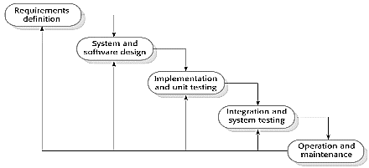
Waterfall model phases: •There are separate identified phases in the waterfall model: +Requirements analysis and definition +System and software design. +Implementation and unit testing +Integration and system testing +Operation and maintenance •The main drawback of the waterfall model is the difficulty of accommodating change after the process is underway. In principle, a phase has to be complete before moving onto the next phase.
Waterfall model problems: •Inflexible partitioning of the project into distinct stages makes it difficult to respond to changing customer requirements: +Therefore, this model is only appropriate when the requirements are well-understood and changes will be fairly limited during the design process.
+Few business systems have stable requirements. •The waterfall model is mostly used for large systems engineering projects where a system is developed at several sites: +In those circumstances, the plan-driven nature of the waterfall model helps coordinate the work.
Incremental development benefits: •The cost of accom-modating changing customer requirements is reduced: +The amount of analysis and documentation that has to be redone is much less than is required with the waterfall model. •It is easier to get customer feedback on the development work that has been done: +Customers can comment on demonstrations of the software and see how much has been implemented. •More rapid delivery and deployment of useful software to the customer is possible: +Customers are able to use and gain value from the software earlier than is possible with a waterfall process.
Incremental development:
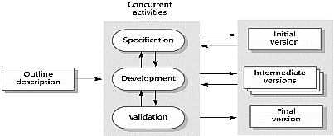
Incremental development problems: •The process is not visible: +Managers need regular deliverables to measure progress. If systems are developed quickly, it is not cost-effective to produce documents that reflect every version of the system. •System structure tends to degrade as new increments are added: +Unless time and money is spent on refactoring to improve the software, regular change tends to corrupt its structure. Incorporating further software changes becomes increasingly difficult and costly.
Integration and configuration: •Based on software reuse where systems are integrated from existing components or application systems (sometimes called COTS -Commercial-off-the-shelf) systems). •Reused elements may be configured to adapt their behaviour and functionality to a user’s requirements. •Reuse is now the standard approach for building many types of business system.
Types of reusable software: •Stand-alone application systems (sometimes called COTS) that are configured for use in a particular environment. •Collections of objects that are developed as a package to be integrated with a component framework such as .NET or J2EE. •Web services that are developed according to service standards and which are available for remote invocation.
Reuse-oriented software engineering:
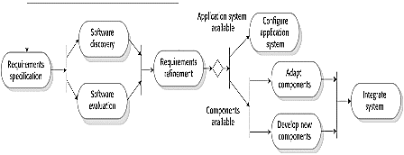
Key process stages: •Requirements specification •Software discovery and evaluation •Requirements refinement •Application system configuration •Component adaptation and integration
Advantages and disadvantages: •Reduced costs and risks as less software is developed from scratch. •Faster delivery and deployment of system. •But requirements compromises are inevitable so system may not meet real needs of users. •Loss of control over evolution of reused system elements.
Process activities
•Real software processes are inter-leaved sequences of technical, collaborative and managerial activities with the overall goal of specifying, designing, implementing and testing a software system. •The four basic process activities of specification, development, validation and evolution are organized differently in different development processes. •For example, in the waterfall model, they are organized in sequence, whereas in incremental development they are interleaved.
Software specification (requirements engineering)
Def: Software specification or requirements engineering is the process of understanding and defining what services are required from the system and identifying the constraints on the system’s operation and development. Requirements engineering is a particularly critical stage of the software process as errors at this stage inevitably lead to later problems in the system design and implementation. Purpose: to produce an agreed requirements document that specifies a system satisfying stakeholder requirements. Requirements engineering process:
The requirements engineering process
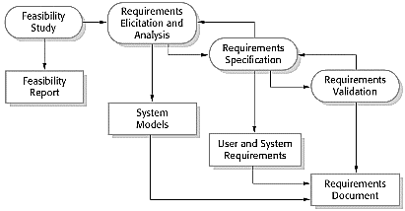
1.Feasibility study:The study considers whether the proposed system will be cost-effective from a business point of view and if it can be developed within existing budgetary constraints. A feasibility study should be relatively cheap and quick. 2.Requirements elicitation and analysis:This is the process of deriving the system requirements through observation of existing systems, discussions with poten- tial users and procurers, task analysis, and so on. = What do the system stakeholders require or expect from the system?
3. Requirements specification:the activity of trans- lating the information gathered during the analysis activity into a document that defines a set of requirements.4. Requirements validation:This activity checks the requirements for realism, consistency, and completeness.
Software design and implementation:
•The process of converting a system specification into an executable system. +A software design is a description of the structure of the software to be implemented, the data models and structures used by the system, the interfaces between system components and, sometimes, the algorithms used. +Implementation:Translate this structure into an executable program; •The activities of design and implementation are closely related and may be interleaved.
A general model of the design process:
Design activities: 1.Architectural design: where you identify the overall structure of the system, the principal components (sometimes called sub-systems or modules), their rela- tionships, and how they are distributed.2.Interface design: where you define the interfaces between system components. This interface specification must be unambiguous. Once interface specifications are agreed, the components can be designed and developed concurrently.3.Component selection and design: where you search for reusable components. If unavailable, you design how it will operate.4.Database design: where you design the system data structures and how these are to be represented in a database.
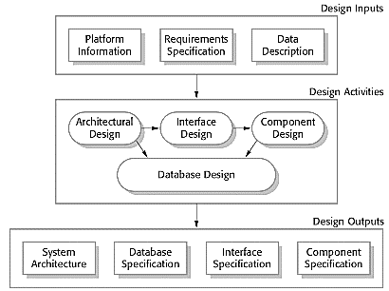
System implementation
•The software is implemented either by developing a program or programs or by configuring an application system.•Design and implementation are interleaved activities for most types of software system. •Programming is an individual activity with no standard process. •Debugging is the activity of finding program faults and correcting these faults.
Software validation
•Verification and validation (V&V) is intended to show that a system both conforms to its specification and that it meets the expectations of the system customer. •Validation involve checking processes, such as inspections and reviews, at each stage of the software process from user requirements definition to program development. •System testing involves executing the system with test cases that are derived from the specification of the real data to be processed by the system. •Testing is the most commonly used V&V activity.
Stages of testing
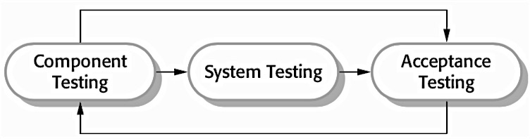
+Component testing:the components making up the system are tested by the people developing the system. Each component is tested independently.Components may be simple entities such as functions or object classes, or may be coherent groupings of these entities.+System testing:Testing of the system as a whole. Testing of emergent properties is particularly important. +Acceptance Testing( Customer testing):This is the final stage in the testing process, testing with customer data to check that the system meets the customer’s needs, reveal errors and omissions in the system requirements definition.
Testing phases in a plan-driven software process (V-model)
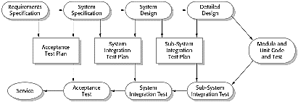
Software evolution
•Software is inherently flexible and can change.•As requirements change through changing business circumstances, the software that supports the business must also evolve and change.•Although there has been a demarcation between development and evolution (maintenance) this is increasingly irrelevant as fewer and fewer systems are completely new.
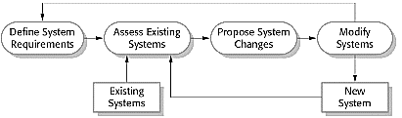
Coping with change
•Change is inevitable in all large software projects. +Business changes lead to new and changed system requirements. +New technologies open up new possibilities for improving implementations. +Changing platforms require application changes. •Change leads to rework so the costs of change include both rework (e.g. re-analysing requirements) as well as the costs of implementing new functionality.
Reducing the costs of rework
1. Change anticipation: where the software process includes activities that can anticipate possible changes before significant rework is required. Ex: a prototype system may be developed to show some key features of the system to customers. They can experiment with the prototype and refine their requirements before committing to high software production costs.2.Change tolerance: where the process is designed so that changes can be accommodated at relatively low cost. This normally involves some form of incremental development. Proposed changes may be implemented in increments that have not yet been developed. If this is impossible, then only a single increment (a small part of the system) may have to be altered to incorporate the change.
Ways of coping with change and changing system requirements
1.System prototyping:where a version of the system or part of the system is developed quickly to check the customer’s requirements and the feasibility of design decisions. This approach supports change anticipation.
2.Incremental delivery:where system increments are delivered to the customer for comment and experimentation. This supports both change avoidance and change tolerance.
Software prototyping
Def: A prototype is an initial version of a software system that is used to demonstrate concepts, try out design options, and find out more about the problem and its possible solutions.
Usage: A prototype can be used in:+The requirements engineering process to help with the elicitation and validation of system requirements. +In the system design process, a prototype can be used to explore particular soft- ware solutions and to support user interface design. +In the testing process to run back-to-back tests. Benefit of prototyping: +Improve the system usability. +A closer match to user’s real need. +Improve design quality. +Improve maintainability. +Reduce development effort.
Prototype development
•May be based on rapid prototyping languages or tools. •May involve leaving out functionality. +Prototype should focus on areas of the product that are not well- understood. +Error checking and recovery may not be included in the prototype. +Focus on functional rather than nonfunctional requirements such as reliability and security
The process of prototype development:
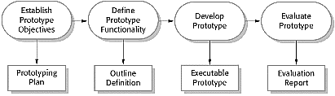
Throw-away prototypes
•Prototypes should be discarded after development as they are not a good basis for a production system: +It may be impossible to tune the system to meet non-functional requirements. +Prototypes are normally undocumented. +The prototype structure is usually degraded through rapid
change. +The prototype probably will not meet normal organisational quality standards.
Incremental delivery
•An approach to software development where some of the developed increments are delivered to the customer and deployed for use in an operational environment. Deliver the system as a single delivery, the development and delivery is broken down into increments with each increment delivering part of the required functionality. •User requirements are prioritised and the highest priority requirements are included in early increments. •Once the development of an increment is started, the requirements are frozen though requirements for later increments can continue to evolve.
Incremental development and delivery
1. Incremental development:•Develop the system in increments and evaluate each increment before proceeding to the development of the next increment. •Normal approach used in agile methods. •Evaluation done by user/customer proxy. 2.Incremental delivery: •Deploy an increment for use by end-users. •More realistic evaluation about practical use of software. •Difficult to implement for replacement systems as increments have less functionality than the system being replaced.
Incremental delivery process:
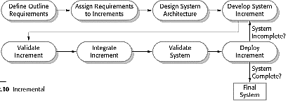
Incremental delivery advantages:
•Customer value can be delivered with each increment so system functionality is available earlier. •Early increments act as a prototype to help elicit requirements for later increments. •Lower risk of overall project failure. •The highest priority system services tend to receive the
most testing.
Incremental delivery problems:
•Most systems require a set of basic facilities that are used by different parts of the system. As requirements are not defined in detail until an increment is to be implemented, it can be hard to identify common facilities that are needed by all increments. •Iterative development can also be difficult when a replacement system is being developed. Users want all of the functionality of the old system and are often unwilling to experiment with an incomplete new system. Therefore, getting use- ful customer feedback is difficult. •The essence of iterative processes is that the specification is developed in conjunc- tion with the software. However, this conflicts with the procurement model of many organizations, where the complete system specification is part of the system development contract.
Process improvement
•Many software companies have turned to software process improvement as a way of enhancing the quality of their software, reducing costs or accelerating their development processes. •Process improvement means understanding existing processes and changing these processes to increase product quality and/or reduce costs and development time.
Approaches to improvement
•The process maturity approach, which focuses on improving process and project management and introducing good software engineering practice.The level of process maturity reflects the extent to which good technical and management practice has been adopted in organizational software development processes. •The agile approach, which focuses on iterative development and the reduction of overheads in the software process.The primary characteristics of agile methods are rapid delivery of functionality and responsiveness to changing customer requirements.
The process improvement cycle
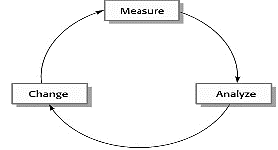
Process improvement activities: •Process measurement:you measure one or more attributes of the software process or product. These measurements forms a baseline that helps you decide if process improvements have been effective.•Process analysis:The current process is assessed, and process weaknesses and bottlenecks are identified. Process models (sometimes called process maps) that describe the process may be developed. •Process change: Process changes are proposed to address some of the identified process weaknesses. These are introduced and the cycle resumes to collect data about the effectiveness of the changes.
Process measurement: •Wherever possible, quantitative process data should be collected. However, where organisations do not have clearly defined process standards this is very difficult as you don’t know what to measure. A process may have to be defined before any measurement is possible. •Process measurements should be used to assess process improvements. But this does not mean that measurements should drive the improvements. The improvement driver should be the organizational objectives.
Process metrics:
•Time taken for process activities to be completed. Ex: Calendar time or effort to complete an activity or process. •Resources required for processes or activities. Ex:Total effort in person-days. •Number of occurrences of a particular event. Ex: Number of defects discovered.
Capability maturity levels
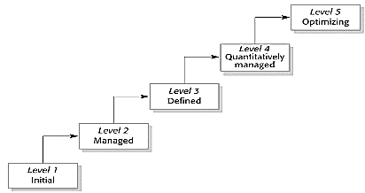
The SEI capability maturity model: •Initial:Essentiallyuncontrolled. •Repeatable: Product management procedures defined and used. •Defined:Process management procedures and strategies defined and used. •Managed:Quality management strategies defined and used. •Optimising: Process improvement strategies defined and used.
Key points: •Software processes are the activities involved in producing a software system. Software process models are abstract representations of these processes. •General process models describe the organization of software processes. Examples of these general models include the ‘waterfall’ model, incremental development, and reuse-oriented development. •Requirements engineering is the process of developing a software specification. •Design and implementation processes are concerned with transforming a requirements specification into an executable software system. •Software validation is the process of checking that the system conforms to its specification and that it meets the real needs of the users of the system. •Software evolution takes place when you change existing software systems to meet new requirements. The software must evolve to remain useful. •Processes should include activities such as prototyping and incremental delivery to cope with change. •Processes may be structured for iterative development and delivery so that changes may be made without disrupting the system as a whole. •The principal approaches to process improvement are agile approaches, geared to reducing process overheads, and maturity-based approaches based on better process management and the use of good software engineering practice. •The SEI process maturity framework identifies maturity levels that essentially correspond to the use of good software engineering practice.
CHAPTER 3 – AGILE SOFTWARE DEVELOPMENT
Rapid software development: •Rapid development and delivery is now often the most important requirement for software systems: +Businesses operate in a fast–changing requirement and it is practically impossible to produce a set of stable software requirements +Software has to evolve quickly to reflect changing business needs. •Plan-driven development is essential for some types of system but does not meet these business needs. •Agile development methods emerged in the late 1990s whose aim was to radically reduce the delivery time for working software systems.
Agile development: •Program specification, design and implementation are inter-leaved. •The system is developed as a series of versions or increments with stakeholders involved in version specification and evaluation. •Frequent delivery of new versions for evaluation •Extensive tool support (e.g. automated testing tools) used to support development. •Minimal documentation – focus on working code.
Plan-driven and agile development:
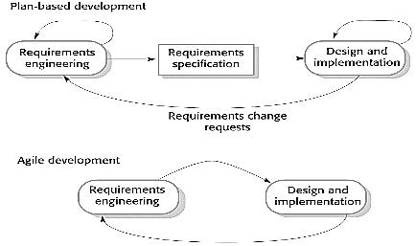
•Plan-driven development: +A plan-driven approach to software engineering is based around separate development stages with the outputs to be produced at each of these stages planned in advance. +Not necessarily waterfall model – plan-driven, incremental development is possible. +Iteration occurs within activities. •Agile development: +Specification, design, implementation and testing are inter-leaved and the outputs from the development process are decided through a process of negotiation during the software development process.
Agile methods:
•Dissatisfaction with the overheads involved in software design methods of the 1980s and 1990s led to the creation of agile methods. These methods: +Focus on the code rather than the design +Are based on an iterative approach to software development +Are intended to deliver working software quickly and evolve this quickly to meet changing requirements. •The aim of agile methods is to reduce overheads in the software process (e.g. by limiting documentation) and to be able to respond quickly to changing requirements without excessive rework.
Agile manifesto: •We are uncovering better ways of developing software by doing it and helping others do it. Through this work we have come to value: +Individuals and interactions over processes and tools Working software over comprehensive documentation Customer collaboration over contract negotiation Responding to change over following a plan. •That is, while there is value in the items on the right, we value the items on the left more.
The principles of agile methods: (Principle: Description)
•Customer involvement: Customers should be closely involved throughout the development process. Their role is provide and prioritize new system requirements and to evaluate the iterations of the system.
•Incremental delivery: The software is developed in increments with the customer specifying the requirements to be included in each increment.
•People not process: The skills of the development team should be recognized and exploited. Team members should be left to develop their own ways of working without prescriptive processes.
•Embrace change: Expect the system requirements to change and so design the system to accommodate these changes.
•Maintain simplicity: Focus on simplicity in both the software being developed and in the development process. Wherever possible, actively work to eliminate complexity from the system.
Agile method applicability: •Product development where a software company is developing a small or medium-sized product for sale: +Virtually all software products and apps are now developed using an agile approach. •Custom system development within an organization, where there is a clear commitment from the customer to become involved in the development process and where there are few external rules and regulations that affect the software.
Agile development techniques:
Extreme programming: •A very influential agile method, developed in the late 1990s, that introduced a range of agile development techniques. •Extreme Programming (XP) takes an ‘extreme’ approach to iterative development: +New versions may be built several times per day; +Increments are delivered to customers every 2 weeks; +All tests must be run for every build and the build is only accepted if tests run successfully.
The extreme programming release cycle:
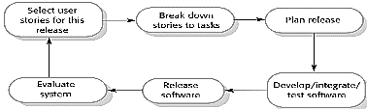
Extreme programming practices: (Principle or practice: Description)
•Incremental planning: Requirements are recorded on story cards and the stories to be included in a release are determined by the time available and their relative priority. The developers break these stories into development ‘Tasks’.
•Small releases: The minimal useful set of functionality that provides business value is developed first. Releases of the system are frequent and incrementally add functionality to the first release.
•Simple design: Enough design is carried out to meet the current requirements and no more.
•Test-first development: An automated unit test framework is used to write tests for a new piece of functionality before that functionality itself is implemented.
•Refactoring: All developers are expected to refactor the code continuously as soon as possible code improvements are found. This keeps the code simple and maintainable.
•Pair programming: Developers work in pairs, checking each other’s work and providing the support to always do a good job.
•Collective ownership: The pairs of developers work on all areas of the system, so that no islands of expertise develop and all the developers take responsibility for all of the code. Anyone can change anything.
•Continuous integration: As soon as the work on a task is complete, it is integrated into the whole system. After any such integration, all the unit tests in the system must pass.
•Sustainable pace: Large amounts of overtime are not considered acceptable as the net effect is often to reduce code quality and medium term productivity
•On-site customer: A representative of the end-user of the system (the customer) should be available full time for the use of the XP team. In an extreme programming process, the customer is a member of the development team and is responsible for bringing system requirements to the team for implementation.
XP and agile principles: •Incremental development is supported through small, frequent system releases. •Customer involvement means full-time customer engagement with the team. •People not process through pair programming, collective ownership and a process that avoids long working hours. •Change supported through regular system releases. •Maintaining simplicity through constant refactoring of
code.
Influential XP practices: •Extreme programming has a technical focus and is not easy to integrate with management practice in most organizations. •Consequently, while agile development uses practices from XP, the method as originally defined is not widely used. •Key practices: +User stories for specification +Refactoring +Test-first development +Pair programming
User stories for requirements: •In XP, a customer or user is part of the XP team and is responsible for making decisions on requirements. •User requirements are expressed as user stories or scenarios. •These are written on cards and the development team break them down into implementation tasks. These tasks are the basis of schedule and cost estimates. •The customer chooses the stories for inclusion in the next release based on their priorities and the schedule estimates.
Refactoring: •Conventional wisdom in software engineering is to design for change. It is worth spending time and effort anticipating changes as this reduces costs later in the life cycle. •XP, however, maintains that this is not worthwhile as changes cannot be reliably anticipated. •Rather, it proposes constant code improvement (refactoring) to make changes easier when they have to be implemented. •Programming team look for possible software improvements and make these improvements even where there is no immediate need for them. •This improves the understandability of the software and so reduces the need for documentation. •Changes are easier to make because the code is well- structured and clear. •However, some changes requires architecture refactoring and this is much more expensive.
Examples of refactoring: Re-organization of a class hierarchy to remove duplicate code. •Tidying up and renaming attributes and methods to make them easier to understand. •The replacement of inline code with calls to methods that have been included in a program library.
A ‘prescribing medication’ story:
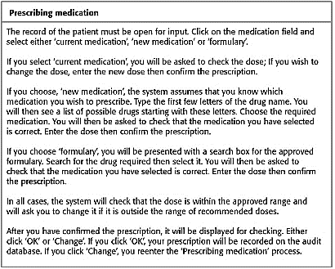
Examples of task cards for prescribing medication:
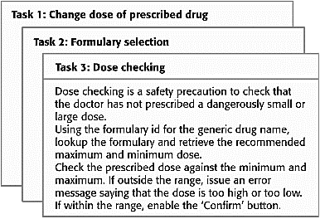
Test-first development: •Testing is central to XP and XP has developed an approach where the program is tested after every change has been made. •XP testing features: +Test-first development. +Incremental test development from scenarios. +User involvement in test development and validation. +Automated test harnesses are used to run all component tests each time that a new release is built.
Test-driven development: •Writing tests before code clarifies the requirements to be implemented. •Tests are written as programs rather than data so that they can be executed automatically. The test includes a check that it has executed correctly. •Usually relies on a testing framework such as Junit. •All previous and new tests are run automatically when new functionality is added, thus checking that the new functionality has not introduced errors.
Customer involvement: The role of the customer in the testing process is to help develop acceptance tests for the stories that are to be implemented in the next release of the system. •The customer who is part of the team writes tests as development proceeds. All new code is therefore validated to ensure that it is what the customer needs. •However, people adopting the customer role have limited time available and so cannot work full-time with the development team. They may feel that providing the requirements was enough of a contribution and so may be reluctant to get involved in the testing process.
Test case description for dose checking:
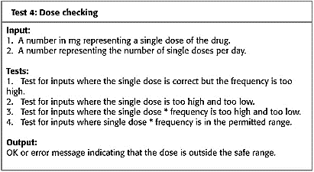
Test automation: Test automation means that tests are written as executable components before the task is implemented: +These testing components should be stand-alone, should simulate the submission of input to be tested and should check that the result meets the output specification. An automated test framework (e.g. Junit) is a system that makes it easy to write executable tests and submit a set of tests for execution. •As testing is automated, there is always a set of tests that can be quickly and easily executed: +Whenever any functionality is added to the system, the tests can be run and problems that the new code has introduced can be caught immediately.
Problems with test-first development: •Programmers prefer programming to testing and sometimes they take short cuts when writing tests. For example, they may write incomplete tests that do not check for all possible exceptions that may occur. •Some tests can be very difficult to write incrementally. For example, in a complex user interface, it is often difficult to write unit tests for the code that implements the ‘display logic’ and workflow between screens. •It difficult to judge the completeness of a set of tests. Although you may have a lot of system tests, your test set may not provide complete coverage.
Pair programming: Pair programming involves programmers working in pairs, developing code together. •This helps develop common ownership of code and spreads knowledge across the team. •It serves as an informal review process as each line of code is looked at by more than 1 person. •It encourages refactoring as the whole team can benefit from improving the system code. •In pair programming, programmers sit together at the same computer to develop the software. •Pairs are created dynamically so that all team members work with each other during the development process. •The sharing of knowledge that happens during pair programming is very important as it reduces the overall risks to a project when team members leave. •Pair programming is not necessarily inefficient and there is some evidence that suggests that a pair working together is more efficient than 2 programmers working separately.
Agile project management: •The principal responsibility of software project managers is to manage the project so that the software is delivered on time and within the planned budget for the project. •The standard approach to project management is plan- driven. Managers draw up a plan for the project showing what should be delivered, when it should be delivered and who will work on the development of the project deliverables. •Agile project management requires a different approach, which is adapted to incremental development and the practices used in agile methods.
Scrum: •Scrum is an agile method that focuses on managing iterative development rather than specific agile practices. •There are three phases in Scrum: +The initial phase is an outline planning phase where you establish the general objectives for the project and design the software architecture. +This is followed by a series of sprint cycles, where each cycle develops an increment of the system. +The project closure phase wraps up the project, completes required documentation such as system help frames and user manuals and assesses the lessons learned from the project.
Scrum terminology: (Scrum term: Definition)
•Development team: A self-organizing group of software developers, which should be no more than 7 people. They are responsible for developing the software and other essential project documents.
•Potentially shippable product increment: The software increment that is delivered from a sprint. The idea is that this should be ‘potentially shippable’ which means that it is in a finished state and no further work, such as testing, is needed to incorporate it into the final product. In practice, this is not always achievable.
•Product backlog: This is a list of ‘to do’ items which the Scrum team must tackle. They may be feature definitions for the software, software requirements, user stories or descriptions of supplementary tasks that are needed, such as architecture definition or user documentation.
•Product owner: An individual (or possibly a small group) whose job is to identify product features or requirements, prioritize these for development and continuously review the product backlog to ensure that the project continues to meet critical business needs. The Product Owner can be a customer but might also be a product manager in a software company or other stakeholder representative.
•Scrum: A daily meeting of the Scrum team that reviews progress and prioritizes work to be done that day. Ideally, this should be a short face-to-face meeting that includes the whole team.
•ScrumMaster: The ScrumMaster is responsible for ensuring that the Scrum process is followed and guides the team in the effective use of Scrum. He or she is responsible for interfacing with the rest of the company and for ensuring that the Scrum team is not diverted by outside interference. The Scrum developers are adamant that the ScrumMaster should not be thought of as a project manager. Others, however, may not always find it easy to see the difference.
•Sprint: A development iteration. Sprints are usually 2-4 weeks long.
•Velocity: An estimate of how much product backlog effort that a team can cover in a single sprint. Understanding a team’s velocity helps them estimate what can be covered in a sprint and provides a basis for measuring improving performance.
Scrum sprint cycle:
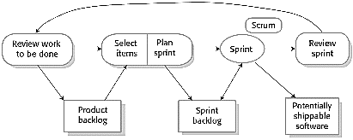
•Sprints are fixed length, normally 2–4 weeks. •The starting point for planning is the product backlog, which is the list of work to be done on the project. •The selection phase involves all of the project team who work with the customer to select the features and functionality from the product backlog to be developed during the sprint.
The Sprint cycle: •Once these are agreed, the team organize themselves to develop the software. •During this stage the team is isolated from the customer and the organization, with all communications channelled through the so-called ‘Scrum master’. •The role of the Scrum master is to protect the development team from external distractions. •At the end of the sprint, the work done is reviewed and presented to stakeholders. The next sprint cycle then begins.
Teamwork in Scrum: •The ‘Scrum master’ is a facilitator who arranges daily meetings, tracks the backlog of work to be done, records decisions, measures progress against the backlog and communicates with customers and management outside of the team. •The whole team attends short daily meetings (Scrums) where all team members share information, describe their progress since the last meeting, problems that have arisen and what is planned for the following day: +This means that everyone on the team knows what is going on and, if problems arise, can re-plan short-term work to cope with them.
Scrum benefits: •The product is broken down into a set of manageable and understandable chunks. •Unstable requi-rements do not hold up progress. •The whole team have visibility of everything and consequently team commu-nication is improved. •Customers see on-time delivery of increments and gain feedback on how the product works. •Trust between customers and developers is established and a positive culture is created in which everyone expects the project to succeed.
Distributed Scrum:
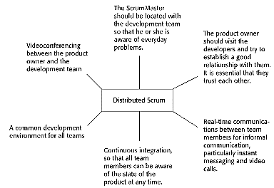
Scaling agile methods: •Agile methods have proved to be successful for small and medium sized projects that can be developed by a small co-located team. •It is sometimes argued that the success of these methods comes because of improved communications which is possible when everyone is working together. •Scaling up agile methods involves changing these to cope with larger, longer projects where there are multiple development teams, perhaps working in different locations.
Scaling out and scaling up: •‘Scaling up’ is concerned with using agile methods for developing large software systems that cannot be developed by a small team. •‘Scaling out’ is concerned with how agile methods can be introduced across a large organization with many years of software development experience. •When scaling agile methods it is important to maintain agile fundamentals: +Flexible planning, frequent system releases, continuous integration, test-driven development and good team communications.
Practical problems with agile methods: •The informality of agile development is incompatible with the legal approach to contract definition that is commonly used in large companies. •Agile methods are most appropriate for new software development rather than software maintenance. Yet the majority of software costs in large companies come from maintaining their existing software systems. •Agile methods are designed for small co-located teams yet much software development now involves worldwide distributed teams.
Contractual issues: •Most software contracts for custom systems are based around a specification, which sets out what has to be implemented by the system developer for the system customer. •However, this precludes interleaving specification and development as is the norm in agile development. •A contract that pays for developer time rather than functionality is required: +However, this is seen as a high risk my many legal departments because what has to be delivered cannot be guaranteed.
Agile methods and software maintenance: Most organizations spend more on maintaining existing software than they do on new software development. So, if agile methods are to be successful, they have to support maintenance as well as original development. •Two key issues: +Are systems that are developed using an agile approach maintainable, given the emphasis in the development process of minimizing formal documentation? +Can agile methods be used effectively for evolving a system in response to customer change requests? •Problems may arise if original development team cannot be maintained.
Agile maintenance: •Key problems are: +Lack of product documentation +Keeping customers involved in the development process +Maintaining the continuity of the development team. •Agile development relies on the development team knowing and understanding what has to be done. •For long-lifetime systems, this is a real problem as the original developers will not always work on the system.
Agile and plan-driven methods: •Most projects include elements of plan-driven and agile processes. Deciding on the balance depends on: +Is it important to have a very detailed specification and design before moving to implementation? If so, you probably need to use a plan-driven approach. +Is an incremental delivery strategy, where you deliver the software to customers and get rapid feedback from them, realistic? If so, consider using agile methods. +How large is the system that is being developed? Agile methods are most effective when the system can be developed with a small co-located team who can communicate informally. This may not be possible for large systems that require larger development teams so a plan-driven approach may have to be used.
Agile principles and organizational practice: (Principle: Practice)
•Customer involvement: This depends on having a customer who is willing and able to spend time with the development team and who can represent all system stakeholders. Often, customer representatives have other demands on their time and cannot play a full part in the software development. Where there are external stakeholders, such as regulators, it is difficult to represent their views to the agile team.
•Embrace change: Prioritizing changes can be extremely difficult, especially in systems for which there are many stakeholders. Typically, each stakeholder gives different priorities to different changes.
•Incremental delivery: Rapid iterations and short-term planning for development does not always fit in with the longer-term planning cycles of business planning and marketing. Marketing managers may need to know what product features several months in advance to prepare an effective marketing campaign.
•Maintain simplicity: Under pressure from delivery schedules, team members may not have time to carry out desirable system simplifications.
•People not process: Individual team members may not have suitable personalities for the intense involvement that is typical of agile methods, and therefore may not interact well with other team members.
Agile and plan-based factors:
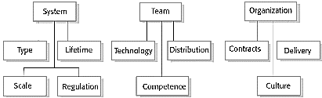
System issues: •How large is the system being developed? +Agile methods are most effective a relatively small co-located team who can communicate informally. •What type of system is being developed? +Systems that require a lot of analysis before implementation need a fairly detailed design to carry out this analysis. •What is the expected system lifetime? +Long-lifetime systems require documentation to communicate the intentions of the system developers to the support team. •Is the system subject to external regulation? +If a system is regulated you will probably be required to produce detailed documentation as part of the system safety case.
People and teams: •How good are the designers and programmers in the development team? +It is sometimes argued that agile methods require higher skill levels than plan-based approaches in which programmers simply translate a detailed design into code. •How is the development team organized? +Design documents may be required if the team is distributed. •What support technologies are available? +IDE support for visualization and program analysis is essential if design documentation is not available.
Organizational issues: Traditional engineering organizations have a culture of plan-based development, as this is the norm in engineering. •Is it standard organizational practice to develop a detailed system specification? •Will customer representatives be available to provide feedback of system increments? •Can informal agile development fit into the organizational culture of detailed documentation?
Agile methods for large systems: •Large systems are usually collections of separate, communicating systems, where separate teams develop each system. Frequently, these teams are working in different places, sometimes in different time zones. •Large systems are ‘brownfield systems’, that is they include and interact with a number of existing systems. Many of the system requirements are concerned with this interaction and so don’t really lend themselves to flexibility and incremental development. •Where several systems are integrated to create a system, a significant fraction of the development is concerned with system configuration rather than original code development.
Large system development: •Large systems and their development processes are often constrained by external rules and regulations limiting the way that they can be developed. •Large systems have a long procurement and development time. It is difficult to maintain coherent teams who know about the system over that period as, inevitably, people move on to other jobs and projects. •Large systems usually have a diverse set of stakeholders. It is practically impossible to involve all of these different stakeholders in the development process.
Factors in large systems:
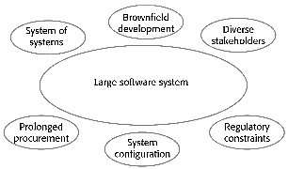

Scaling up to large systems: •A completely incremental approach to requirements engineering is impossible. •There cannot be a single product owner or customer representative. •For large systems development, it is not possible to focus only on the code of the system. •Cross-team communication mechanisms have to be designed and used. •Continuous integration is practically impossible. However, it is essential to maintain frequent system builds and regular releases of the system.
Multi-team Scrum: •Role replication: Each team has a Product Owner for their work component and ScrumMaster. •Product architects: Each team chooses a product architect and these architects collaborate to design and evolve the overall system architecture. •Release alignment: The dates of product releases from each team are aligned so that a demonstrable and complete system is produced. •Scrum of Scrums: There is a daily Scrum of Scrums where representatives from each team meet to discuss progressand plan work to be done.
Agile methods across organizations: •Project managers who do not have experience of agile methods may be reluctant to accept the risk of a new approach. •Large organizations often have quality procedures and standards that all projects are expected to follow and, because of their bureaucratic nature, these are likely to be incompatible with agile methods. •Agile methods seem to work best when team members have a relatively high skill level. However, within large organizations, there are likely to be a wide range of skills and abilities. •There may be cultural resistance to agile methods, especially in those organizations that have a long history of using conventional systems engineering processes.
Key points: •Agile methods are incremental development methods that focus on rapid software development, frequent releases of the software, reducing process overheads by minimizing documentation and producing high-quality code. •Agile development practices include: +User stories for system specification +Frequent releases of the software +Continuous software improvement +Test-first development +Customer participation in the development team. •Scrum is an agile method that provides a project management framework: +It is centred round a set of sprints, which are fixed time periods when a system increment is developed. •Many practical development methods are a mixture of plan-based and agile development. •Scaling agile methods for large systems is difficult: +Large systems need up-front design and some documentation and organizational practice may conflict with the informality of agile approaches.
CHAPTER 4 – REQUIREMENTS ENGINEERING
Requirements engineering: •The process of establishing the services that a customer requires from a system and the constraints under which it operates and is developed. •The system requirements are the descriptions of the system services and constraints that are generated during the requirements engineering process.
What is a requirement? •It may range from a high-level abstract statement of a service or of a system constraint to a detailed mathematical functional specification. •This is inevitable as requirements may serve a dual function: +May be the basis for a bid for a contract - therefore must be open to interpretation; +May be the basis for the contract itself-therefore must be defined in detail; +Both these statements may be called requirements.
Types of requirement: •User requirements: +Statements in natural language plus diagrams of the services the system provides and its operational constraints. Written for customers. •System requirements: +A structured document setting out detailed descriptions of the system’s functions, services and operational constraints. Defines what should be implemented so may be part of a contract between client and contractor.
User and system requirements:
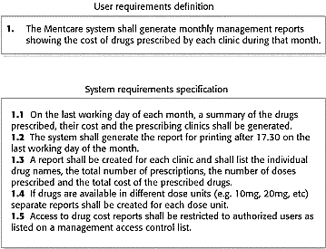
Readers of different types of requirements specification:
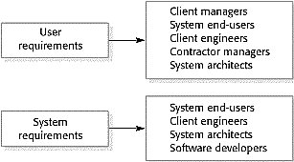
System stakeholders: •Any person or organization who is affected by the system in some way and so who has a legitimate interest •Stakeholder types: +End users +System managers +System owners +External stakeholders
Stakeholders in the Mentcare system: •Patients whose information is recorded in the system. •Doctors who are responsible for assessing and treating patients. •Nurses who coordinate the consultations with doctors and administer some treatments. •Medical receptionists who manage patients’ appointments. •IT staff who are responsible for installing and maintaining the system. •A medical ethics manager who must ensure that the system meets current ethical guidelines for patient care. •Health care managers who obtain management information from the system. •Medical records staff who are responsible for ensuring that system information can be maintained and preserved, and that record keeping procedures have been properly implemented.
Functional and non-functional requirements:
•Functional requirements: +Statements of services the system should provide, how the system should react to particular inputs and how the system should behave in particular situations. +May state what the system should not do. •Non-functional requirements: +Constraints on the services or functions offered by the system such as timing constraints, constraints on the development process, standards, etc. +Often apply to the system as a whole rather than individual features or services. •Domain requirements +Constraints on the system from the domain of operation.
Functional requirements: •Describe functionality or system services. •Depend on the type of software, expected users and the type of system where the software is used. •Functional user requirements may be high-level statements of what the system should do. •Functional system requirements should describe the system services in detail.
Mentcare system: functional requirements: •A user shall be able to search the appointments lists for all clinics. •The system shall generate each day, for each clinic, a list of patients who are expected to attend appointments that day. •Each staff member using the system shall be uniquely identified by his or her 8-digit employee number.
Requirements imprecision: •Problems arise when functional requirements are not precisely stated. •Ambiguous requi-rements may be interpreted in different ways by developers and users. •Consider the term ‘search’ in requirement 1: +User intention – search for a patient name across all appoint-ments in all clinics; +Developer interpretation – search for a patient name in an individual clinic. User chooses clinic then search.
Requirements completeness and consistency: •In principle, requirements should be both complete and consistent. •Complete: +They should include descriptions of all facilities required. •Consistent: +There should be no conflicts or contradictions in the descriptions of the system facilities. •In practice, because of system and environmental complexity, it is impossible to produce a complete and consistent requi-rements document.
Non-functional requirements: These define system properties and constraints e.g. reliability, response time and storage requirements. Constraints are I/O device capability, system representations, etc. •Process requirements may also be specified mandating a particular IDE, programming language or development method. •Non-functional requirements may be more critical than functional requirements. If these are not met, the system may be useless.
Non-functional requirements implementation: •Non-functional requirements may affect the overall architecture of a system rather than the individual components. +For example, to ensure that performance requirements are met, you may have to organize the system to minimize communications between components. •A single non-functional requirement, such as a security requirement, may generate a number of related functional requirements that define system services that are required. +It may also generate requirements that restrict existing requirements.
Non-functional classifications: •Product requirements: +Requirements which specify that the delivered product must
behave in a particular way e.g. execution speed, reliability, etc. •Organizational requirements: +Requirements which are a consequence of organizational policies and procedures e.g. process standards used, implementation requirements, etc. •External requirements: +Requirements which arise from factors which are external to the system and its development process e.g. interoperability requirements, legislative requirements, etc.
Examples of nonfunctional requirements in the Mentcare system: •Product requirement: The Mentcare system shall be available to all clinics during normal working hours (Mon–Fri, 0830–17.30). Downtime within normal working hours shall not exceed five seconds in any one day. •Organizational requirement: Users of the Mentcare system shall authenticate themselves using their health authority identity card. •External requirement: The system shall implement patient privacy provisions as set out in HStan-03-2006-priv.
Goals and requirements: •Non-functional requirements may be very difficult to state precisely and imprecise requirements may be difficult to verify. •Goal: +A general intention of the user such as ease of use. •Verifiable non-functional requirement: +A statement using some measure that can be objectively tested. •Goals are helpful to developers as they convey the intentions of the system users.
Usability requirements: •The system should be easy to use by medical staff and should be organized in such a way that user errors are minimized. (Goal) •Medical staff shall be able to use all the system functions after four hours of training. After this training, the average number of errors made by experienced users shall not exceed two per hour of system use. (Testable non-functional requirement)
Metrics for specifying nonfunctional requirements:
(Property: Measure)
•Speed: +Processed transactions/second +User/event response time +Screen refresh time
•Size: +Mbytes +Number of ROM chips
•Ease of use: +Training time +Number of help frames
•Reliability: +Mean time to failure +Probability of unavailability +Rate of failure occurrence +Availability
•Robustness: +Time to restart after failure +Percentage of events causing failure +Probability of data corruption on failure
•Portability: +Percentage of target dependent statements +Number of target systems
Requirements engineering processes: •The processes used for RE vary widely depending on the application domain, the people involved and the organization developing the requirements. •However, there are a number of generic activities common to all processes: +Requirements elicitation; +Requirements analysis; +Requirements validation; +Requirements management. •In practice, RE is an iterative activity in which these processes are interleaved.
Requirements elicitation:
Requirements elicitation and analysis: •Sometimes called requirements elicitation or requirements discovery. •Involves technical staff working with customers to find out about the application domain, the services that the system should provide and the system’s operational constraints.
•May involve end-users, managers, engineers involved in maintenance, domain experts, trade unions, etc. These are called stakeholders.
Requirements elicitation: •Software engineers work with a range of system stakeholders to find out about the application domain, the services that the system should provide, the required system performance, hardware constraints, other systems, etc. •Stages include: +Requirements discovery, +Requirements classification and organization, +Requirements prioritization and negotiation, +Requirements specification.
Problems of requirements elicitation: •Stakeholders don’t know what they really want. •Stakeholders express requirements in their own terms. •Different stakeholders may have conflicting requirements. •Organizational and political factors may influence the system requirements. •The requirements change during the analysis process. New stakeholders may emerge and the business environment may change.
The requirements elicitation and analysis process:
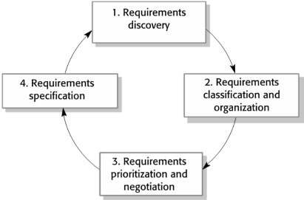
Process activities: •Requirements discovery: +Interacting with stakeholders to discover their requirements. Domain requirements are also discovered at this stage. •Requirements classification and organization: +Groups related requirements and organizes them into coherent clusters. •Prioritization and negotiation: +Prioritizing requirements and resolving requirements conflicts. •Requirements specification: +Requirements are documented and input into the next round of the spiral.
Requirements discovery: •The process of gathering information about the required and existing systems and distilling the user and system requirements from this information. •Interaction is with system stakeholders from managers to external regulators. •Systems normally have a range of stakeholders.
Interviewing: •Formal or informal interviews with stakeholders are part of most RE processes. •Types of interview: +Closed interviews based on pre-determined list of questions +Open interviews where various issues are explored with stakeholders. •Effective interviewing: +Be open-minded, avoid pre-conceived ideas about the requirements and are willing to listen to stakeholders. +Prompt the interviewee to get discussions going using a springboard question, a requirements proposal, or by working together on a prototype system.
Interviews in practice: •Normally a mix of closed and open-ended interviewing. •Interviews are good for getting an overall understanding of what stakeholders do and how they might interact with the system. •Interviewers need to be open-minded without pre-conceived ideas of what the system should do •You need to prompt the use to talk about the system by suggesting requirements rather than simply asking them what they want.
Problems with interviews: •Application specialists may use language to describe their work that isn’t easy for the requirements engineer to understand. •Interviews are not good for understanding domain requirements: +Requirements engineers cannot understand specific domain terminology; +Some domain knowledge is so familiar that people find it hard to articulate or think that it isn’t worth articulating.
Ethnography: •A social scientist spends a considerable time observing and analysing how people actually work. •People do not have to explain or articulate their work. •Social and organisational factors of importance may be observed. •Ethnographic studies have shown that work is usually richer and more complex than suggested by simple system models.
Scope of ethnography: •Requirements that are derived from the way that people actually work rather than the way in which process definitions suggest that they ought to work.
•Requirements that are derived from cooperation and awareness of other people’s activities. +Awareness of what other people are doing leads to changes in the ways in which we do things. •Ethnography is effective for understanding existing processes but cannot identify new features that should be added to a system.
Focused ethnography: •Developed in a project studying the air traffic control process •Combines ethnography with prototyping •Prototype development results in unanswered questions which focus the ethnographic analysis. •The problem with ethnography is that it studies existing practices which may have some historical basis which is no longer relevant.
Ethnography and prototyping for requirements analysis:
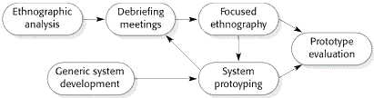
Stories and scenarios: •Scenarios and user stories are real-life examples of how a system can be used. •Stories and scenarios are a description of how a system may be used for a particular task. •Because they are based on a practical situation, stakeholders can relate to them and can comment on their situation with respect to the story.
Photo sharing in the classroom (iLearn): •Jack is a primary school teacher in Ullapool (a village in northern Scotland). He has decided that a class project should be focused around the fishing industry in the area, looking at the history, development and economic impact of fishing. As part of this, pupils are asked to gather and share reminiscences from relatives, use newspaper archives and collect old photographs related to fishing and fishing communities in the area. Pupils use an iLearn wiki to gather together fishing stories and SCRAN (a history resources site) to access newspaper archives and photographs. However, Jack also needs a photo sharing site as he wants pupils to take and comment on each others’ photos and to upload scans of old photographs that they may have in their families. •Jack sends an email to a primary school teachers group, which he is a member of to see if anyone can recommend an appropriate system. Two teachers reply and both suggest that he uses KidsTakePics, a photo sharing site that allows teachers to check and moderate content. As KidsTakePics is not integrated with the iLearn authentication service, he sets up a teacher and a class account. He uses the iLearn setup service to add KidsTakePics to the services seen by the pupils in his class so that when they log in, they can immediately use the system to upload photos from their mobile devices and class computers.
Scenarios: •A structured form of user story •Scenarios should include: +A description of the starting situation; +A description of the normal flow of events; +A description of what can go wrong; +Information about other concurrent activities; +A description of the state when the scenario finishes.
Requirements specification: •The process of writing down the user and system requirements in a requirements document. •User requirements have to be understandable by end- users and customers who do not have a technical background. •System requirements are more detailed requirements and may include more technical information. •The requirements may be part of a contract for the system development: +It is therefore important that these are as complete as possible.
Ways of writing a system requirements specification: (Notation: Description)
•Natural language: The requirements are written using numbered sentences in natural language. Each sentence should express one requirement.
•Structured natural language: The requirements are written in natural language on a standard form or template. Each field provides information about an aspect of the requirement.
•Design description languages: This approach uses a language like a programming language, but with more abstract features to specify the requirements by defining an operational model of the system. This approach is now rarely used although it can be useful for interface specifications.
•Graphical notations: Graphical models, supplemented by text annotations, are used to define the functional requirements for the system; UML use case and sequence diagrams are commonly used.
•Mathematical specifications: These notations are based on mathematical concepts such as finite-state machines or sets. Although these unambiguous specifications can reduce the ambiguity in a requirements document, most customers don’t understand a formal specification. They cannot check that it represents what they want and are reluctant to accept it as a system contract
Requirements and design: •In principle, requirements should state what the system should do and the design should describe how it does this. •In practice, requirements and design are inseparable: +A system architecture may be designed to structure the requirements; +The system may inter-operate with other systems that generate design requirements; +The use of a specific architecture to satisfy non-functional requirements may be a domain requirement. +This may be the consequence of a regulatory requirement.
Natural language specification: •Requirements are written as natural language sentences supplemented by diagrams and tables. •Used for writing requirements because it is expressive, intuitive and universal. This means that the requirements can be understood by users and customers.
Guidelines for writing requirements: Invent a standard format and use it for all requirements. •Use language in a consistent way. Use shall for mandatory requirements, should for desirable requirements. •Use text highlighting to identify key parts of the requirement. •Avoid the use of computer jargon.
•Include an explanation (rationale) of why a requirement
is necessary.
Problems with natural language: •Lack of clarity: +Precision is difficult without making the document difficult to read. •Requirements confusion: +Functional and non-functional requirements tend to be mixed-up. •Requirements amalgamation: +Several different requirements may be expressed together.
Example requirements for the insulin pump software system: •3.2 The system shall measure the blood sugar and deliver insulin, if required, every 10 minutes. (Changes in blood sugar are relatively slow so more frequent measurement is unnecessary; less frequent measurement could lead to unnecessarily high sugar levels.) •3.6 The system shall run a self-test routine every minute with the conditions to be tested and the associated actions defined in Table 1. (A self-test routine can discover hardware and software problems and alert the user to the fact the normal operation may be impossible.)
Structured specifications: •An approach to writing requirements where the freedom of the requirements writer is limited and requirements are written in a standard way. •This works well for some types of requirements e.g. requirements for embedded control system but is sometimes too rigid for writing business system requirements.
Form-based specifications: •Definition of the function or entity. •Description of inputs and where they come from. •Description of outputs and where they go to. •Information about the information needed for the computation and other entities used. •Description of the action to be taken. •Pre and post conditions (if appropriate). •The side effects (if any) of the function.
A structured specification of a requirement for an insulin pump:
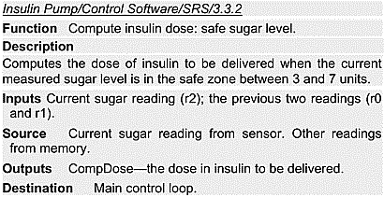
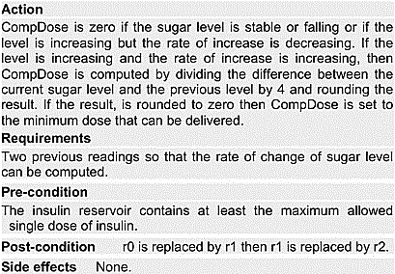
Tabular specification: •Used to supplement natural language.
•Particularly useful when you have to define a number of
possible alternative courses of action. •For example, the insulin pump systems bases its computations on the rate of change of blood sugar level and the tabular specification explains how to calculate the insulin requirement for different scenarios.
Tabular specification of computation for an insulin pump:
Condition | Action Table 2 columns
•Sugar level falling (r2 < r1) | CompDose = 0
•Sugar level stable (r2 = r1) | CompDose = 0
•Sugar level increasing and rate of increase decreasing ((r2 – r1) < (r1 – r0)) | CompDose = 0
•Sugar level increasing and rate of increase stable or increasing ((r2 – r1) ≥ (r1 – r0)) | CompDose = round ((r2 – r1)/4) If rounded result = 0 then CompDose = MinimumDose
Use cases: •Use-cases are a kind of scenario that are included in the UML. •Use cases identify the actors in an interaction and which describe the interaction itself. •A set of use cases should describe all possible interactions with the system. •High-level graphical model supplemented by more detailed tabular description (see Chapter 5). •UML sequence diagrams may be used to add detail to use-cases by showing the sequence of event processing in the system.
Use cases for the Mentcare system:
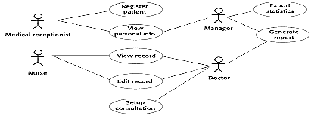
The software requirements document: •The software requirements document is the official statement of what is required of the system developers. •Should include both a definition of user requirements and a specification of the system requirements. •It is NOT a design document. As far as possible, it should set of WHAT the system should do rather than HOW it should do it.
Users of a requirements document:
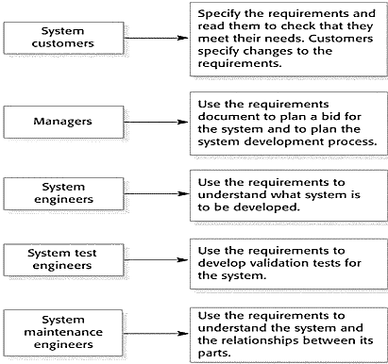
Requirements document variability: •Information in requirements document depends on type of system and the approach to development used. •Systems developed incrementally will, typically, have less detail in the requirements document. •Requirements documents standards have been designed e.g. IEEE standard. These are mostly applicable to the requirements for large systems engineering projects.
The structure of a requirements document: (Chapter: Description)
•Preface: This should define the expected readership of the document and describe its version history, including a rationale for the creation of a new version and a summary of the changes made in each version.
•Introduction: This should describe the need for the system. It should briefly describe the system’s functions and explain how it will work with other systems. It should also describe how the system fits into the overall business or strategic objectives of the organization commissioning the software.
•Glossary: This should define the technical terms used in the document. You should not make assumptions about the experience or expertise of the reader.
•User requirements definition: Here, you describe the services provided for the user. The nonfunctional system requirements should also be described in this section. This description may use natural language, diagrams, or other notations that are understandable to customers. Product and process standards that must be followed should be specified.
•System architecture: This chapter should present a high-level overview of the anticipated system architecture, showing the distribution of functions across system modules. Architectural components that are reused should be highlighted.
•System requirements specification: This should describe the functional and nonfunctional requirements in more detail. If necessary, further detail may also be added to the nonfunctional requirements. Interfaces to other systems may be defined.
•System models: This might include graphical system models showing the relationships between the system components and the system and its environment. Examples of possible models are object models, data-flow models, or semantic data models.
•System evolution: This should describe the fundamental assumptions on which the system is based, and any anticipated changes due to hardware evolution, changing user needs, and so on. This section is useful for system designers as it may help them avoid design decisions that would constrain likely future changes to the system.
•Appendices: These should provide detailed, specific information that is related to the application being developed; for example, hardware and database descriptions. Hardware requirements define the minimal and optimal configurations for the system. Database requirements define the logical organization of the data used by the system and the relationships between data.
•Index: Several indexes to the document may be included. As well as a normal alphabetic index, there may be an index of diagrams, an index of functions, and so on.
Requirements validation: •Concerned with demonstrating that the requirements define the system that the customer really wants. •Requirements error costs are high so validation is very important: + Fixing a requirements error after delivery may cost up to 100 times the cost of fixing an implementation error.
Requirements checking: •Validity. Does the system provide the functions which best support the customer’s needs? •Consistency. Are there any requirements conflicts? •Completeness. Are all functions required by the customer included? •Realism. Can the requirements be implemented given available budget and technology. •Verifiability. Can the requirements be checked?
Requirements validation techniques: •Requirements reviews: +Systematic manual analysis of the requirements. •Prototyping: +Using an executable model of the system to check requirements. •Test-case generation: +Developing tests for requirements to check testability.
Requirements reviews: •Regular reviews should be held while the requirements definition is being formulated. •Both client and contractor staff should be involved in reviews. •Reviews may be formal (with completed documents) or informal. Good communications between developers, customers and users can resolve problems at an early stage.
Review checks: •Verifiability: +Is the requirement realistically testable? •Comprehensibility: Is the requirement properly understood? •Traceability: +Is the origin of the requirement clearly stated? •Adaptability: +Can the requirement be changed without a large impact on other requirements?
Requirements change:
Changing requirements: •The business and technical environment of the system always changes after installation. +New hardware may be introduced, it may be necessary to interface the system with other systems, business priorities may change (with consequent changes in the system support required), and new legislation and regulations may be introduced that the system must necessarily abide by. •The people who pay for a system and the users of that system are rarely the same people. +System customers impose requirements because of organizational and budgetary constraints. These may conflict with end-user requirements and, after delivery, new features may have to be added for user support if the system is to meet its goals. •Large systems usually have a diverse user community, with many users having different requirements and priorities that may be conflicting or contradictory. +The final system requirements are inevitably a compromise between them and, with experience, it is often discovered that the balance of support given to different users has to be changed.
Requirements evolution:
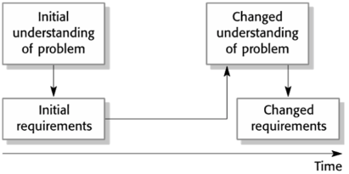
Requirements management: •Requirements management is the process of managing changing requirements during the requirements engineering process and system development. •New requirements emerge as a system is being developed and after it has gone into use. •You need to keep track of individual requirements and maintain links between dependent requirements so that you can assess the impact of requirements changes. You need to establish a formal process for making change proposals and linking these to system requirements.
Requirements management planning: •Establishes the level of requirements management detail that is required. •Requirements management decisions: +Requirements identification Each requirement must be uniquely identified so that it can be cross-referenced with other requirements. +A change management process This is the set of activities that assess the impact and cost of changes. I discuss this process in more detail in the following section. +Traceability policies These policies define the relationships between each requirement and between the requirements and the system design that should be recorded. +Tool support Tools that may be used range from specialist requirements management systems to spreadsheets and simple database systems.
Requirements change management: •Deciding if a requirements change should be accepted +Problem analysis and change specification: During this stage, the problem or the change proposal is analyzed to check that it is valid. This analysis is fed back to the change requestor who may respond with a more specific requirements change proposal, or decide to withdraw the request. +Change analysis and costing: The effect of the proposed change is assessed using traceability information and general knowledge of the system requirements. Once this analysis is completed, a decision is made whether or not to proceed with the requirements change. +Change implementation: The requirements document and, where necessary, the system design and implementation, are modified. Ideally, the document should be organized so that changes can be easily implemented.
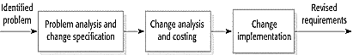
Key points: •Requirements for a software system set out what the system should do and define constraints on its operation and implementation. •Functional requirements are statements of the services that the system must provide or are descriptions of how some computations must be carried out. •Non-functional requirements often constrain the system being developed and the development process being used. •They often relate to the emergent properties of the system and therefore apply to the system as a whole. •The requirements engineering process is an iterative process that includes requirements elicitation, specification and validation. •Requirements elicitation is an iterative process that can be represented as a spiral of activities – requirements discovery, requirements classification and organization, requirements negotiation and requirements documentation. •You can use a range of techniques for requirements elicitation including interviews and ethnography. User stories and scenarios may be used to facilitate discussions. •Requirements specification is the process of formally documenting the user and system requirements and creating a software requirements document. •The software requirements document is an agreed statement of the system requirements. It should be organized so that both system customers and software developers can use it. •Requirements validation is the process of checking the requirements for validity, consistency, completeness, realism and verifiability. •Business, organizational and technical changes inevitably lead to changes to the requirements for a software system. Requirements management is the process of managing and controlling these changes.

Chapter 1: Introduction
1. What are the essential attributes of good software? ●Maintainability, dependability and security, efficiency and acceptability
2. What are the two fundamental types of software product?
●Generic products that are designed to meet the needs of many different
customers. ●Customised products designed to meet the specific needs of a single customer.
3. What is software engineering? An engineering discipline concerned with all aspects of software production from specification to system maintenance.
4. What are the four fundamental activities in software processes? Software specification, software development, software validation and
software evolution
5. What is the distinction between computer science and software
engineering? Computer science is concerned with theories and methods of computers and software systems; software engineering is concerned with the practice of software production.
6. What are the 3 general issues that affect many different types of
software? ●Heterogeneity. Software may have to execute on several different types of system. ●Business and social change, which drives requirements for software change. ●Security and trust – our software systems have to be secure against external and internal threats so that we can trust those systems.
7. List 5 different types of software application.
Any 5 from stand-alone products, interactive transaction-based systems,
embedded control systems, batch processing systems, entertainment
systems, systems for modelling and simulation, data collection systems,
systems of systems.
8. What software engineering fundamentals apply to all types of software
●Systems should be developed using a managed and understood
development process. ●Dependability and performance are key system characteristics ●Understanding and managing the software specification and requirements are important. ● Effective use should be made of available resources.
9. What are three key characteristics of the engineering of web-based
software engineering? Software reuse is the principal approach for constructing web-based systems, requirements for those systems cannot be completely specified in advance, User interfaces are constrained by the
capabilities of web browsers.
10. What is a software out, in a general way, standards of expected
behaviour for professional software engineers. A set of principles that set out, in a general way, standards of expected behaviour for professional software engineers.
Chapter 3: Agile Software Development
1. What are the shared characteristics of different approaches to rapid
software development? ●The processes of specification, design and implementation are inter-leaved. ● The system is developed and delivered as a series of versions. ●User interfaces are often developed using an interactive development system that supports rapid UI development.
2. For what types of system are agile approaches to development
particularly likely to be successful? ●Small and medium-sized software product development. ●Custom software development in an organization where there is a clear commitment from customers to become involved in the development process.
3. List the 5 principles of agile methods. ●Customer involvement, ●Incremental delivery, ●People not process, ●Embrace change, ●Maintain simplicity.
4. List 4 questions that should be asked when deciding whether or not to
adopt an agile method of software development. ●Is an incremental delivery strategy realistic? ●What type of system is being developed?
What is the expected system lifetime? ●How is the development team organized? ●Is the system subject to external regulation? ●How large is the system that is being developed?
5. What are three important characteristics of extreme programming?
●Requirements expressed as scenarios, ●Pair programming, ●Test-first development.
6. What is test-first development?
When a system feature is identified, the tests of the code implementing that feature are written before the code. Tests are automated and all tests are run when a new increment is added to the system.
7. What are the possible problems of test-first development?
●Programmers may take short-cuts when developing tests so that the
system tests are incomplete. ●Some tests can be difficult to write incrementally. ●It is difficult to estimate the completeness of a test set.
8. Briefly describe the advantages of pair programming.
●It supports the idea of common ownership and responsibility for the code. ●It serves as an informal code review process. ●It helps support refactoring.
9. What is a Scrum sprint?
A short (3-4 weeks) planning unit in which work to be done is assessed,
features are selected for development, the software is implemented and
delivered to system stakeholders.
10. What are the barriers to introducing agile methods into large companies?
● Project managers may be reluctant to accept the risks of a new approach. ●The established quality procedures in large companies may be incompatible with the informal approach to documentation in agile methods. ●The existing teams may not have the high level of skills to make use of agile methods. ●There may be cultural resistance if there is a long history of plan-driven development in the company.
1. Explain the principles of agile methods in the way you are understanding, and give examples. ●1. Incremental development is supported through small, frequent releases of the sys. Requirements are based on simple customer stories or scenarios that are used as a basis for deciding what functionality should be included in a sys increment.
E.g.: some simple / basic functions are released first, and modified more then. ●2. Customer involvement is supported through the continuous engagement of the customer in the development team. The customer representative takes part in the development and is responsible for defining acceptance tests for the sys. E.g.: some customers are involved in the development team to give feedback regularly. ●3. People, not process, are supported through pair programming, collective ownership of the sys code, and a sustainable development process that does not involve excessively long working hours. E.g.: In the team, person A who is good at HTML is assigned to jobs of designing user interface pages, person B who is good at Java will do coding the back-end part... ●4. Change is embraced through regular sys releases to customers, test-first development, refactoring to avoid code degeneration, and continuous integration of new functionality. Eg.: create some test cases first, then implement functions for the test cases. Functions are implemented incrementally. ●5. Maintaining simplicity is supported by constant refactoring that improves code quality and by using simple designs that do not unnecessarily anticipate future changes to the sys. E.g.: implement simple functions enough for use
2. Discuss the following extreme programming practices, and give examples for each.
Pair programming: Developers work in pairs, checking each other’s work and providing the support to always do a good job. E.g.: one member codes and the other one supports Collective ownership
The pairs of developers work on all areas of the sys, so that no islands ofexpertise develop and all the developers take responsibility for all of the code. Anyone can change anything .E.g.: whenever a member codes a function, others can see and modify. Continuous integration: As soon as the work on a task is complete, it is integrated into the whole sys. After
any such integration, all the unit tests in the sys must pass.E.g.: when a member finishes a task/function, it will be put into the sys. Sustainable pace: Large amounts of overtime are not considered acceptable as the net effect is often to reduce code quality and medium term productivity
E.g.: leave the advanced functionalities for later versions to deliver the product on time. On-site customer: A representative of the end-user of the sys (the Customer) should be available full time for the use of the XP team. In an extreme programming process, the customer is a member of the development team and is responsible for bringing sys requirements to the team for implementation. E.g.: a member of the product development team is a customer who will provide requirements directly
Chapter 4: Requirements Engineering
1. What are user requirements and system requirements? Give examples of your current project. ● User requirements are statements in a language that is understandable to a user of what services the system should provide and the constraints under which it operates. ●System requirements are more detailed descriptions of the system services and
constraint, written for developers of the system.
2. What is the distinction between functional and non-functional requirements? Give examples of your current project. ●Functional requirements define what the system should do. Non-functional requirements are not directly concerned with specific system functions but specify required system properties or place constraints on the system or its development process.
3. List 3 types of non-functional requirement?
●Product requirements, that specify or constrain the softwareʼs behaviour.
●Organisational requirements, are general requirements derived from policies and procedures in the customerʼs organization. ●External requirements, which cover all requirements derived from factors external to the system and its development process.
4. What is the software requirements document?
The official document that defines the requirements that should be implemented by the system developers.
5. What are the main advantages of using a standard format to specify requirements?
●All requirements have the same format so are easier to read, ●The definition of form fields mean that writers are less likely to forget to include information ● Some automated processing is possible.
6. What are the principal stages of the requirements engineering process?
●Requirements elicitation and analysis●Requirements specification
● Requirements validation
7. Give 5 reasons why eliciting requirements is difficult? ●Stakeholders donʼt know what they want ● Stakeholders use their own language that requirements engineers may not understand. ● Stakeholder requirements may conflict ● Political factors may influence the system requirements
● The business environment may change during elicitation.
8. What should be included in a scenario? Give an example of your current project
●A description of whatʼs expected when the scenario starts ● A description of the normal flow of events ● A description of what can go wrong and how to handle it ● Information about concurrent activities
●A description of the system state when the scenario finishes
9. What is a use-case? Give an example of your current project.
A use-case identifies a typical interaction with a system and the actors (human or computer) involved in that interaction.
10. What is ethnography and how is it used in requirements elicitation?
Ethnography is an observational technique where an analyst spends a period of time observing work and noting how the participants carry out their tasks. It is particularly useful in identifying essential cooperation in work processes.
11. What checks should be applied during requirements validation?
●Validity checks ● Consistency checks ● Completeness checks ● Realism checks ● The verifiability of the requirements should be assessed.
12. List three requirements validation techniques?
●Requirements reviews● Prototyping ●Test-case generation
TEST BANK SOFTWARE ENGINEERING
1. Software consists of _____.
a. Set of instructions + operating procedures
b. Programs + documentation + operating procedures
c. Programs + hardware manuals
d. Set of programs
2. The process of developing a software product using software engineering principles and methods is referred to as, _______ .
a. Software myths
b. Scientific Product
c. Software Evolution
d. None of the above
3. Software when made for a specific requirement is called, Software Product.
a. Yes
b. No
4. What is the level of metrics and indicators that are available to measure the process and quality?
a. Optimized
b. Defined
c. Quantitatively Managed
d. Managed
5. If the software process were not based on scientific and engineering concepts it would be easier to re-create new software than to scale an existing one, is known as________ .
a. Cost
b. Dynamic Management
c. Large Software
d. Scalability
6. Choose the correct option according to the given statement.
Statement 1: Software is a physical rather than a logical system element.
Statement 2: Computer software is the product that software engineers design and build.
Statement 3: Software is a logical rather than a physical system element.
Statement 4: Software is a set of application programs that are built by software engineers.
a. Statement 1 and 2 are correct.
b. Only Statement 2 and 3 are correct.
c. Statement 2 and 3 and 4 are correct.
d. All statements are correct
7. What is the main aim of Software engineering?
a. Reliable software
b. Cost effective software
c. Reliable and cost effective software
d. None of the above
8. First level of prototype is evaluated by ______ .
a. Developer
b. Tester
c. User
d. System Analyst
9. If you have no clue of how to improve the process for the quality software which model is used?
a. A Continuous model
b. A Staged model
c. Both A & B
d. None of the above
10. Which of the level carries out goal, objective, work tasks, work products and other activities of the software process?
a. Performed
b. INCOMPLETE
c. Optimized
d. Quantitatively Managed
11. Which model is also called as the classic life cycle or the Waterfall model?
a. Iterative Development
b. Linear Sequential Development
c. RAD Model.
d. Incremental Development
12. A generic process framework for software engineering encompasses five activities. What are those activities?
a. Communication, risk management,
measurement, production, deployment.
b. Communication, Planning, Modeling, construction, deployment.
c. Analysis, designing, programming, debugging, maintenance
d. None of the above.
13. Software Engineering is defined as systematic, disciplined and quantifiable approach for the development, operation and maintenance of software.
a. True
b. False
14. Design phase is followed by ______ .
a. Coding
b. Testing
c. Maintenance
d. None of the above.
15. Where is the prototyping model of software development well suited?
a. When requirements are well defined.
b. For projects with large development teams.
c. When a customer cannot define requirements clearly.
d. None of the above.
16. CMM model in Software Engineering is a technique of ______ .
a. Develop the software.
b. Improve the software process.
c. Improve the testing process.
d. All of the above.
17. Project risk factor is considered in which model?
a. Spiral model.
b. Waterfall model.
c. Prototyping model
d. None of the above.
18. Which of the following is/are Project Estimation Technique?
a. Empirical Estimation Technique.
b. Heuristic Estimation Technique.
c. Analytical Estimation Technique.
d. All of the above.
19. What is the meaning of requirement elicitation in software engineering?
a. Gathering of requirement.
b. Understanding of requirement.
c. Getting the requirements from client.
d. All of the above.
20. If requirements are easily understandable and defined then which model is best suited?
a. Spiral model
b. Waterfall model
c. Prototyping model
d. None of the above
21. RAD Software process model stands for _____ .
a. Rapid Application Development.
b. Relative Application Development.
c. Rapid Application Design.
d. Recent Application Development.

